Prospectus Project

Development of an Inquiry Professional Development Workshop in an Informal Institution

Melissa A Bogan UIN: 814785413
Submitted: July 5, 2015

SSE 6617: Trends in Science
Instructor: Dr. Michael Boucher

College of Education
Florida Gulf Coast University

Development of an Inquiry Professional Development Workshop in an Informal Institution
Topic:
This curriculum development project will be a professional development workshop for teachers. The development will introduce the inquiry method, demonstrate examples, allow teachers to practice the method under guidance, and to reflect on it.
Need:
There has been a huge push in recent years to reform the way formal science education is taught (Bell et al. 2005, Binns & Popp 2013, NRC 1996, NRC 2000). This push has been to incorporate inquiry based instruction into science classrooms. Throughout history inquiry has had many definitions. Colburn (2000) defines it as “The creation of a classroom where students are engaged in essentially open ended, student centered, hands on activities.” Bell et al. (2005) defines it as “The inquiry method is a active learning process in which students answer research questions through data analysis.” While Savery (2006) defines it as “A student centered learning approach that focuses on questions, critical thinking, and problem solving.” What all the definitions seem to agree on is that the students are engaged with the content, they are working with questions and data to understand and explore concepts.
Multiple studies have been conducted on teaching pre-service teachers inquiry based pedagogies along with studying whether current teachers are using inquiry pedagogies (Binns & Popp 2013, Cherian 2007, Colburn 2000, Marshall et al. 2009). These studies have found that while a few teachers are using the inquiry method most are not due to challenges presented by the formal system. Some of the misconceptions that teachers have about the inquiry method is that it is too complex for the K-12 setting, that all science concepts should be taught through inquiry, and that inquiry only works with high ability students (Marshall et. al 2009, NRC 2000, Welch et al. 1981). Most pre-service teachers commented that exploring new teaching techniques was not encouraged or supported in their classroom practicum because their mentors lacked knowledge or experience with inquiry (Anderson et al. 2006, Borko & Putman 1996, Welch et al. 1981). When current teachers were asked about including the inquiry method most responses were that it was to time consuming, there was a pressure to stick to the curriculum, and it caused classroom management issues (Binns&Poop 2013, Cherian 2007, Lustick 2009, Marshall et al. 2009, Uno 1990, Welch et al. 1981)
A solution to this problem would be to utilize the informal field to show easy methods of incorporating inquiry through professional development (Anderson et al. 2006, NRC 2000, NSTA 2012, Phillips et al. 2007). Informal educators use the inquiry method in their everyday jobs. In turn they could share their experiences with formal educators of how to teach hands on inquiry based activates and projects. This would best be done through professional development courses where the formal educator learned about inquiry and then had the chance to apply it while under the guidance of an informal educator (Anderson et al. 2006, NRC 2000, NSTA 2012,Phillips et al. 2007).
Purpose:
Once this project is complete a professional development workshop that focuses on inquiry will be available for an informal institution. This development workshop will address a requirement that students be taught through the inquiry method by helping teachers understand the method and practice with it.
Daily Plans:
Unit Information - This professional development workshop will take place over a two week period in an aquarium. Week one will be spent in the classroom in the mornings and out in the institution in the afternoon shadowing an educator. Week two will have the teachers take an active role in working the institution and applying the inquiry method while under the guidance of an educator. Two hours at the end of the day will be dedicated to discussion and reflection.
- Lesson 1: Introduce the Inquiry Method
  - Day 1 Morning
Big Idea | What is the Inquiry Method?
Objectives | Students will be able to explain what the inquiry method is.
Formative Assessment | - Listening to the discussions and the summary shared during the graffiti model to discover the teacher’s ideas about inquiry.  - The paragraph that teachers will write in their journal at the end of the direct instruction explaining what the inquiry method is.
Step by Step Plan | Cooperative Learning - Graffiti Model: Teachers will be split into three groups to answers questions designed to discover what pre-conceptions teachers have about the inquiry teaching method.  - Questions:  - What is the inquiry method?  - Do you think it can be used in any subject area?  - Do you think it has a place in the K-12 setting?  - Distribute Materials: Questions will be pre-laminated strips of paper. Each group will be given one question.  - Group Answer Questions: Groups will have five minutes to discuss each question. Time will be kept with a visually displayed stop watch. Each group will be asked to summarize their thoughts about each question.  - Exchange Questions: Questions will be passed to the group on the left.  - Original Question: Once the original question has returned to the group the group will be asked to take their summaries from all the questions and synthesize them into an overall summary.  - Share information: Each group will be asked to share their summarized thoughts about the inquiry method.  Direct Instruction: Have a short lecture about the inquiry method and the different levels. Show the short video that summarizes the inquiry method at the beginning to give teachers a place to start building. Also show the short video that presents the benefits of inquiry teaching.  Assessment: Ask the teachers to write a paragraph in their journal an explanation of what the inquiry method is. Educators will collect journals at the end of the night to read explanations.
Materials | Laminated question sheets for the graffiti model.  Desk area set up for students  Paper and pen for each of the teachers  Computer and projector screen to show the video during the direct instruction  Computer and projector screen to show the PowerPoint
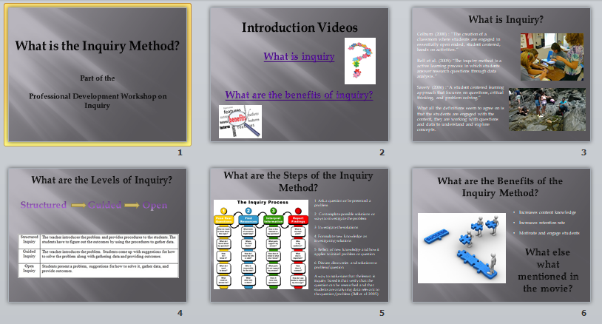
  - Day 1 Afternoon
Big Idea | How is the Inquiry Method used at this facility?
Objectives | Students will be able to explain how inquiry was used throughout the day
Formative Assessment | - Looking at the journal teachers will be required to keep in the observation section.
Step by Step Plan | Peer Tutoring: Each teacher will be paired with an informal educator to shadow as they hold classes or work the floor to see the inquiry method in action. Spend a half hour before end of the day in reflection and writing in their journal ways that inquiry was used throughout the day.
Materials | Not applicable.
- Lesson 2: Challenges and Solutions
  - Day 2 Morning
Big Idea | What are the Challenges of using the Inquiry Method in the Formal Classroom?
Objectives | Students will be able to describe the challenges of including the inquiry method into a classroom.  Students will be able to develop solutions to the challenges of including the inquiry method into a classroom.
Formative Assessment | - Reviewing the teacher’s synthesize of challenges to incorporating inquiry located in their journal.  - Reviewing teacher’s solutions to their assigned challenge from the literature located in their journals.
Step by Step Plan | Concept Development: Teachers will be paired up in twos and asked to brainstorm challenges with incorporating inquiry into the classroom  - List as Many Items as Possible: Teachers will be provided sticky notes on which to write their ideas. The question will be “Challenges to including inquiry.” They will have two minutes for this part.  - Group the Items: Teachers will then be asked to group their ideas based on similarities. They will have five minutes for this part.  - Label the Groups: Teachers will be asked to create labels for their groups. They will have five minutes for this part.  - Regroup: Teachers will have five minutes to reorganize their ideas and their groups based on the labels they have given them.  - Synthesize: Teachers will be asked to summarize the big ideas for why inquiry may be a challenge to utilize in the classroom and write it in their journal.  Cooperative Learning – Jigsaw: Groups will discuss the challenges to incorporating inquiry into the classroom and brainstorm ideas of how to mitigate them.  - Assign expert and learning groups: teachers will be assigned to their expert group and their learning groups randomly.  - Explain task: Each expert group will be given one of the problems they suggested from the previous exercise to explore and brainstorm how to mitigate. After an hour they will then switch into their learning groups where each expert will present their problem and their groups solutions for how to mitigate it.  - Expert Groups: Each group will be given an hour to discuss their problem, use technology to search for solution, and prepare a hand out that they can use in their learning groups.  - Learning Groups: Each group will be given an hour to learn about the solutions to other problems.  - Group Discussion: After the learning groups the teachers will have a discussion to see if the solutions presented would elevate the challenges of incorporating inquiry into the classroom.  Assessment: Each teacher will be given one of the challenges with including inquiry in the classroom that was listed in the literature. Examples – too complex for the k-12 setting, inquiry only works with high level students, consumes too much time, etc. They will then be asked to explain in their journals a way to work around that challenge.
Materials | Desk area set up for students  Pack of sticky notes for each group  Pen for each of the teachers  Large sheet of chart paper for each group  Computer and projector screen to display the digital stopwatch  Computers for the teachers to research solutions during the jigsaw  Computer with printers so teachers can print out handouts for teaching their learning groups
  - Day 2 Afternoon
Big Idea | How is the Inquiry Method used at this facility?
Objectives | Students will be able to explain how inquiry was used throughout the day
Formative Assessment | - Looking at the journal teachers will be required to keep in the observation section.
Step by Step Plan | Peer Tutoring: Each teacher will be paired with an informal educator to shadow as they hold classes or work the floor to see the inquiry method in action. Spend a half hour before end of the day in reflection and writing in their journal ways that inquiry was used throughout the day.
Materials | Not applicable.
- Lesson 3:
  - Day 3 Morning
Big Idea | What do Students do when using Structured Inquiry?
Objectives | Students will be able to identify the structured inquiry level.  Students will be able to explain the steps of structured inquiry.  Students will be able to design activates that utilize structured inquiry.
Formative Assessment | - Identification of structured inquiry level will be observed during the reflection discussion.  - Teachers will list the steps of the structured inquiry method in their journals.  - Teachers will design five activities they could use structured inquiry with in their subject area. This information will be recorded in their journals.
Step by Step Plan | Inquiry Method, Structured: Provide the teachers with a problem, marine pollution, and a set of procedures (data sheet) for determining pollution during a beach cleanup. Have the teachers go to an adjacent waterway and collect data and hypothesize the health of the waterway based on their data.  Reflection Discussion: Teachers will be asked the following questions: “What inquiry level did you just work through?” “Why was it that level?” For the inquiry level teachers will be asked to raise their hands with which of the three levels they believed it was. This will allows the observation of whether the teachers were able to correctly identify it.  Assessment: Teachers will be asked to list the steps of the structured inquiry into their journals. They will also be asked to design five activities that utilize structured inquiry within their subject area.
Materials | Trash bags, gloves, transportation to the site, clipboards, pens
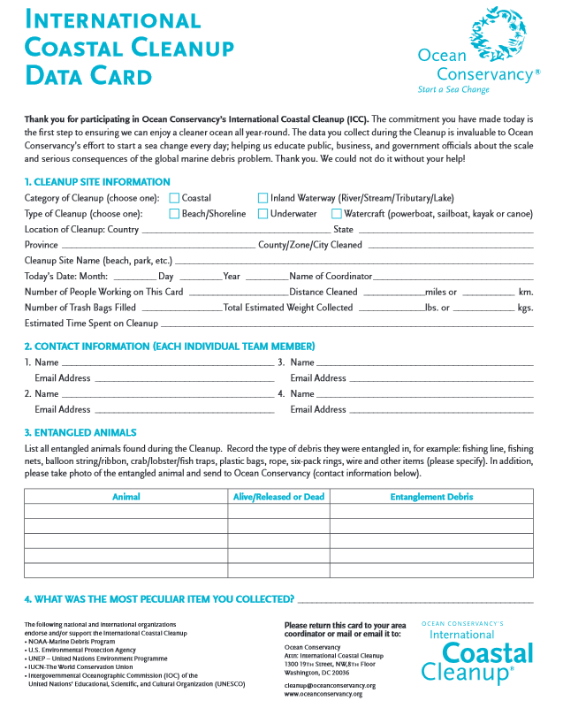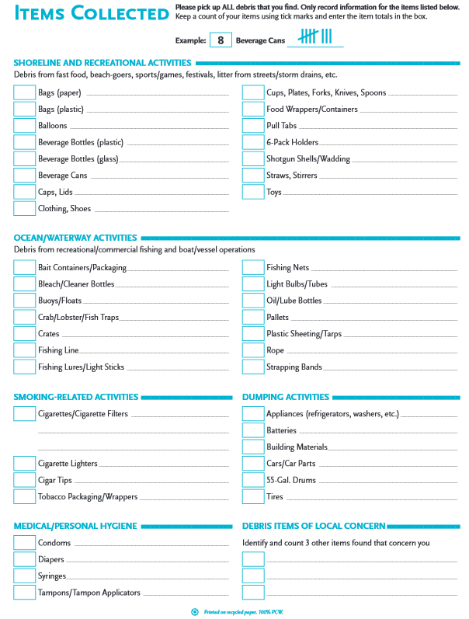
  - Day 3 Afternoon
Big Idea | How is the Inquiry Method used at this facility?
Objectives | Students will be able to explain how inquiry was used throughout the day
Formative Assessment | - Looking at the journal teachers will be required to keep in the observation section.
Step by Step Plan | Peer Tutoring: Each teacher will be paired with an informal educator to shadow as they hold classes or work the floor to see the inquiry method in action. Spend a half hour before end of the day in reflection and writing in their journal ways that inquiry was used throughout the day.
Materials | Not applicable.

- Lesson 4:
  - Day 4 Morning
Big Idea | What do Students do when using Guided Inquiry?
Objectives | Students will be able to identify the guided inquiry level.  Students will be able to explain the steps of guided inquiry.  Students will be able to design activates that utilize guided inquiry.
Formative Assessment | - Identification of guided inquiry level will be observed during the reflection discussion.  - Teachers will list the steps of the guided inquiry method in their journals.  - Teachers will design five activities they could use guided inquiry with in their subject area. This information will be recorded in their journals.
Step by Step Plan | Inquiry Method, Guided: Explain that the problem is that people do not understand the impact that they have on their local waterways. Have the teachers design a way to inform the locals, plan a way to collect data, and then ways to interpret it to make sure their campaign is having an effect.  Reflection Discussion: Teachers will be asked the following questions: “What inquiry level did you just work through?” “Why was it that level?” For the inquiry level teachers will be asked to raise their hands with which of the three levels they believed it was. This will allows the observation of whether the teachers were able to correctly identify it.  Assessment: Teachers will be asked to list the steps of the guided inquiry into their journals. They will also be asked to identify five concepts and design activities that utilize guided inquiry within their subject area.
Materials | This will change depending on what the teachers need for their project at minimum they will need access to computers, printers, and paper.
  - Day 4 Afternoon
Big Idea | How is the Inquiry Method used at this facility?
Objectives | Students will be able to explain how inquiry was used throughout the day
Formative Assessment | - Looking at the journal teachers will be required to keep in the observation section.
Step by Step Plan | Peer Tutoring: Each teacher will be paired with an informal educator to shadow as they hold classes or work the floor to see the inquiry method in action. Spend a half hour before end of the day in reflection and writing in their journal ways that inquiry was used throughout the day.
Materials | Not applicable.

- Lesson 5:
  - Day 5 Morning
Big Idea | What do Students do when using Open Inquiry?
Objectives | Students will be able to identify the guided inquiry level.  Students will be able to explain the steps of guided inquiry.  Students will be able to design activates that utilize guided inquiry.
Formative Assessment | - Identification of open inquiry level will be observed during the reflection discussion.  - Teachers will list the steps of the open inquiry method in their journals.  - Teachers will design one activities they could use open inquiry with in their subject area. This information will be recorded in their journals.
Step by Step Plan | Inquiry Method, Open: Allow the teachers to propose a problem related to the marine environment, suggest procedures, and outcomes.  Reflection Discussion: Teachers will be asked the following questions: “What inquiry level did you just work through?” “Why was it that level?” For the inquiry level teachers will be asked to raise their hands with which of the three levels they believed it was. This will allows the observation of whether the teachers were able to correctly identify it.  Assessment: Teachers will be asked to list the steps of the open inquiry into their journals. They will also be asked to identify one concept and design an activity that utilize open inquiry within their subject area.
Materials | Not really applicable this will change depending on what the teachers need for their courses.

  - Day 5 Afternoon
Big Idea | How is the Inquiry Method used at this facility?
Objectives | Students will be able to explain how inquiry was used throughout the day
Formative Assessment | - Looking at the journal teachers will be required to keep in the observation section.
Step by Step Plan | Peer Tutoring: Each teacher will be paired with an informal educator to shadow as they hold classes or work the floor to see the inquiry method in action. Spend a half hour before end of the day in reflection and writing in their journal ways that inquiry was used throughout the day.
Materials | Content books for the classes that are held at the aquarium.  Examples of what lesson other educators have taught for those classes.

- Lesson 6: Working with the Inquiry Method
  - Day 6 – 10
Big Idea | How to teach with the Inquiry Method?
Objectives | Students will be able to utilize the inquiry method to teach courses.
Formative Assessment | - Observing the teacher teach the course.  - Listening to the teacher’s reflection at the end of the day about using inquiry.
Step by Step Plan | Peer Tutoring: Teachers will be spending the day conducting the institutions classes and spending time staffing the floor to be able to apply the inquiry method. An educator will be shadowing them to make suggestions.  Reflection: Two hours before the end of the day all the teachers will gather in the classroom with the lead educator to discuss the day.
Materials | Not really applicable this will change depending on what the teachers need for their courses.
  - Day 10 Summative Assessment
Big Idea | What is the Inquiry Method?
Objectives | Students will be able to identify the different inquiry levels.  Students will be able to explain how the inquiry levels are different.  Students will be able to describe the challenges of including the inquiry method into a classroom.  Students will be able to develop solutions to the challenges of including the inquiry method into a classroom.
Summative Assessment | Matching: Each term has one definition, please fill in the blank with the correct letter of the terms definition  __ Guided Inquiry  __ Structured Inquiry  __ Open Inquiry  A. Students given problem, asked for procedure and outcome  B. Students present problem, procedure, and outcomes  C. Students given problem and procedure, asked for outcome  Short Response: Minimum two sentences.  - What is the inquiry method?  - What are the benefits of teaching with the inquiry method?  - What are some challenges of teaching with the inquiry method in a formal classroom? How can they be overcome?  - Please give one examples activity for each of the levels of the inquiry method  Please fill out the following organizer  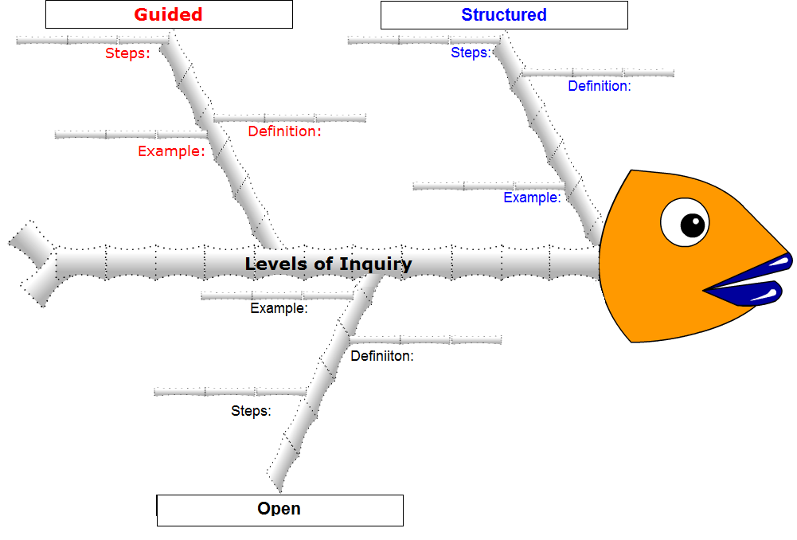
Step by Step Plan | Summative assessment: Instead of spending the last two hours of the day in reflection teachers will only spend an hour in reflection the second hour will be spent taking the end of workshop assessment.
Materials | Assessment printed out for the teachers. Pens to write with.

Evaluation Plan:
This professional development workshop will always be changing to meet the needs of the teachers. Time in week two might be adjusted and split, as it was in week one, if teachers are struggling with the method. If this is the case then the mornings will be spent in the institution conducting classes and working the floor, while the afternoon will be spent in class preparing for the next day. This preparation can be anything from gathering materials and walking through the lesson plan with their partner to reworking the lesson plan to make it inquiry based.
Teachers will be sent a survey halfway through the spring and fall semester to collect data on whether they are using inquiry methods following the workshop and asking for comments.

Literature Review:
Anderson, D., Lawson, B., & Mayer‐Smith, J. (2006) Investigating the Impact of a Practicum Experience in an Aquarium on Pre‐service Teachers. Teaching Education, 17:4, 341-353
Bell, R., Smetana, L, & Binns, I. (2005) Simplifying Inquiry Instruction. The Science Teacher, 72:7, 30-33.
Binns, I., & Popp, S. (2013) Learning to Teach Science Through Inquiry: Experiences of Pre-service Teachers. Journal of Science Education 17:1, 1-24.
Borko, H. & Putman, R.T. (1996). Learning to teach. In D. Berliner & R. Calfee (Eds.) Handbook of research in educational psychology. NY: MacMillian.
Cherian, F. (2007). Learning to teach: Teacher candidates reflect on the relational, conceptual, and contextual influences of responsive mentorship. Canadian Journal of Education, 30, 25-46.
Colburn, A. (2000). An Inquiry Primer. Science Scope, 23:6, 42-44.
Estes, T.H., & Mintz, S.L. (2016). Instructional Models Approach. New Jersey: Pearson 7, 1-336
Falk, J., & Needham, M. (2011). Measuring the Impact of a Science Center on its Community. Journal of Research in Science Teaching, 48:1, 1-12.
Jeffery, K., & Wandersee, J. (1996). Visitor Understanding of Interactive Exhibits: A study of Family Groups in a Public Aquarium. Annual Meeting of the National Association for Research in Science Teaching. St. Louis, MO.
Lustick, D. (2009). The failure of inquiry: Preparing science teachers with an authentic investigation. Journal of Science Teacher Education, 20, 583-604.
Marshall, J., Horton, R., Igo, B.L., & Switzer, D.M. (2009). K-12 Science and Mathematics Teachers’ Beliefs About and Use of Inquiry in the Classroom. International Journal of Science and Mathematics Education, 7, 575-596.
Minner, D. D., Levy, A. J., & Century, J. (2010). Inquiry-based science instruction—what is it and does it matter? Results from a research synthesis years 1984 to 2002. Journal of Research in Science Teaching, 47, 474-496.
National Research Council (NRC). (1996). National science education standards. Washington, DC: National Academy Press.
National Research Council (NRC). (2000). Inquiry and the national science education standards: A guide for teaching and learning. Washington, DC: National Academy Press.
National Science Teachers Association (NSTA). (2012) An NSTA Position Statement: Learning Science in Informal Environments. http://www.nsta.org/about/positions/informal.aspx
Phillips, M., Finkelstein, D., & Wever-Frerichs, S. (2007) School Site to Museum Floor: How Informal Science Institutions Work with Schools. International Journal of Science Education, 29:12, 1489-1507.
Savery, J.R. (2006). Overview of Problem based Learning: Definitions and Distinctions. Interdisciplinary Journal of Problem-Based Learning, 1:1, 9-20.
Uno, G.E. (1990). Inquiry in the Classroom. Bioscience, 40:11, 841-843.
Welch, W.W., L.E. Klopfer, G.E. Aikenhead, et al. (1981). The role of inquiry in science education: Analysis and recommendations. Science Education, 65, 33–50.
Wellington, J. (1990). Formal and Informal Learning in Science: The Role of the Interactive Science Centres. Physics Education, 25:5, 247-252.

